1. **Essential Parts and devices:**

**Description of components:**

**The Raspberry Pi**

The Raspberry Pi is a series of small single-board computers developed by the Raspberry Pi Foundation.

[Operating system](https://www.google.com/search?q=raspberry+pi+operating+system&sa=X&ved=2ahUKEwiVodfM-p7pAhX363MBHRGuBZgQ6BMoADAtegQICBAC): [Android](https://www.google.com/search?q=Android&stick=H4sIAAAAAAAAAONgVuLSz9U3MCqvKEkvX8TK7piXUpSfmQIAyAsAJhgAAAA&sa=X&ved=2ahUKEwiVodfM-p7pAhX363MBHRGuBZgQmxMoATAtegQICBAD); [FreeBSD](https://www.google.com/search?q=FreeBSD&stick=H4sIAAAAAAAAAONgVuLQz9U3MKpMqVjEyu5WlJrqFOwCAOg-RnYWAAAA&sa=X&ved=2ahUKEwiVodfM-p7pAhX363MBHRGuBZgQmxMoAjAtegQICBAE); [Linux](https://www.google.com/search?q=Linux&stick=H4sIAAAAAAAAAONgVuLUz9U3SCuoqipYxMrqk5lXWgEATgerNhUAAAA&sa=X&ved=2ahUKEwiVodfM-p7pAhX363MBHRGuBZgQmxMoAzAtegQICBAF); [NetBSD](https://www.google.com/search?q=NetBSD&stick=H4sIAAAAAAAAAONgVuLQz9U3ME2xMFrEyuaXWuIU7AIA4T6kHBUAAAA&sa=X&ved=2ahUKEwiVodfM-p7pAhX363MBHRGuBZgQmxMoBDAtegQICBAG); [OpenBSD](https://www.google.com/search?q=OpenBSD&stick=H4sIAAAAAAAAAONgVuLQz9U3MM0pz13Eyu5fkJrnFOwCAL211REWAAAA&sa=X&ved=2ahUKEwiVodfM-p7pAhX363MBHRGuBZgQmxMoBTAtegQICBAH); [Plan 9](https://www.google.com/search?q=Plan+9&stick=H4sIAAAAAAAAAONgVuLQz9U3MDNML1zEyhaQk5inYAkAddSH0xUAAAA&sa=X&ved=2ahUKEwiVodfM-p7pAhX363MBHRGuBZgQmxMoBjAtegQICBAI); [RISC OS](https://www.google.com/search?q=RISC+OS&stick=H4sIAAAAAAAAAONgVuLUz9U3MDRLzy1fxMoe5BnsrOAfDABZQYGmFwAAAA&sa=X&ved=2ahUKEwiVodfM-p7pAhX363MBHRGuBZgQmxMoBzAtegQICBAJ); [Windows 10](https://www.google.com/search?q=Windows+10&stick=H4sIAAAAAAAAAONgVuLWz9U3MDQyKE_KrVjEyhWemZeSX16sYGgAAIqtrY8cAAAA&sa=X&ved=2ahUKEwiVodfM-p7pAhX363MBHRGuBZgQmxMoCDAtegQICBAK) [ARM64](https://www.google.com/search?q=ARM64&stick=H4sIAAAAAAAAAONgVuLQz9U3SE-rKl_EyuoY5GtmAgDFrFSbFAAAAA&sa=X&ved=2ahUKEwiVodfM-p7pAhX363MBHRGuBZgQmxMoCTAtegQICBAL); [Windows 10 IoT](https://www.google.com/search?q=Windows+10+IoT&stick=H4sIAAAAAAAAAONgVuLVT9c3NEw2LjcsrDAvWcTKF56Zl5JfXqxgaKDgmR8CAK37ZUgiAAAA&sa=X&ved=2ahUKEwiVodfM-p7pAhX363MBHRGuBZgQmxMoCjAtegQICBAM) Core

[Power](https://www.google.com/search?q=raspberry+pi+power&sa=X&ved=2ahUKEwiVodfM-p7pAhX363MBHRGuBZgQ6BMoADAuegQICRAC): 5V 3A (for full power delivery to [USB](https://www.google.com/search?q=USB&stick=H4sIAAAAAAAAAONgVuLQz9U3MC9PTlvEyhwa7AQAFmp7qRIAAAA&sa=X&ved=2ahUKEwiVodfM-p7pAhX363MBHRGuBZgQmxMoATAuegQICRAD) devices)

[Storage](https://www.google.com/search?q=raspberry+pi+storage&sa=X&ved=2ahUKEwiVodfM-p7pAhX363MBHRGuBZgQ6BMoADAvegQIChAC): MicroSDHC slot

[Memory](https://www.google.com/search?q=raspberry+pi+memory&sa=X&ved=2ahUKEwiVodfM-p7pAhX363MBHRGuBZgQ6BMoADAwegQICxAC)**:**1, 2, or 4 GiB LPDDR4-3200 RAM

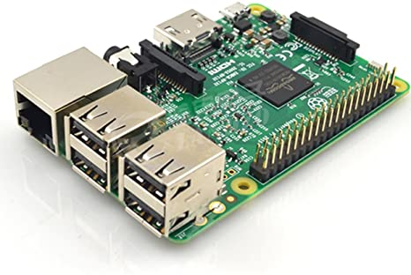

Fig :5 The Raspberry Pi

**Pi Cam:**

The Raspberry Pi Camera v2 is a high quality 8 megapixel Sony IMX219 image sensor custom designed add-on board for Raspberry Pi, featuring a fixed focus lens. 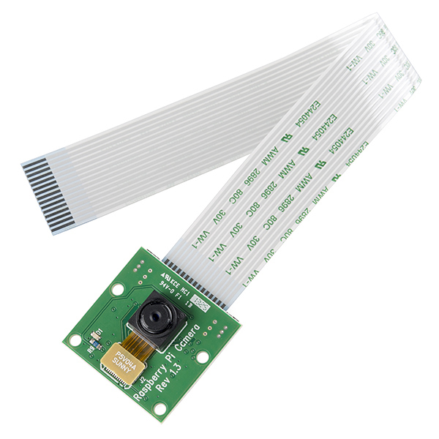

Fig: 6 Pi Cam

**Wi-Fi Module:**

The ESP8266 WiFi Module is a self contained SOC with integrated TCP/IP protocol stack that can give any microcontroller access to your WiFi network.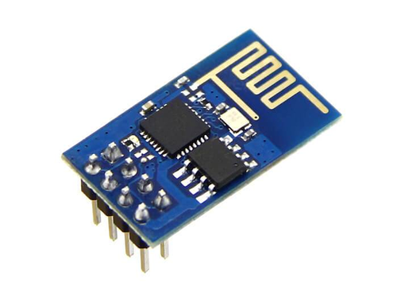

Fig:7 Wi-Fi Module.

**MQ-2 (gas sensor)**

MQ2 gas sensor is an electronic sensor which is used for sensing the concentration of gases in the air such as LPG, propane, methane, hydrogen, alcohol, smoke and carbon monoxide. this sensor is also known as chemiresistor. In this sensor there is a sensing material whose resisteance changes when it senses gas.

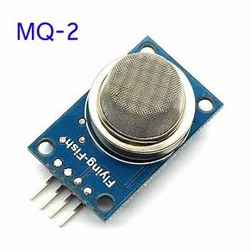

Fig: 8 MQ-2 gas sensor.

**MQ135 (gas sensor)**

The MQ-135 Gas sensors are used in air quality control equipment and are suitable for detecting or measuring of NH3, NOx, Alcohol, Benzene, Smoke, CO2.

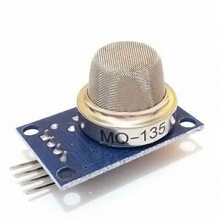

Fig:9 MQ-135 gas sensor.

**Mq-7 (gas sensor)**

Any signal when the sensor is shifted from clean air to carbon monoxide (CO), output signal measurement is made within one or two complete heating period (2.5 minute from high voltage to low voltage). Sensitive layer of MQ-7 gas sensitive components is made of SnO2 with stability, So, this sensor long term stability.

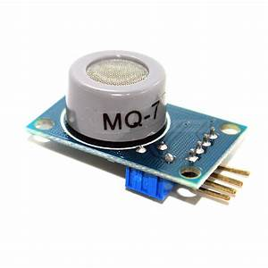

Fig:9 MQ-135 gas sensor.

**PM10 & PM2.5:**

This Particulate Matter (PM) sensor head uses laser and optical counter to measure light scattered from particles passing through the laser beam. The optical sensor then transforms scattered light into electrical signals which are processed to produce mass measurements in PM2.5 and PM10.

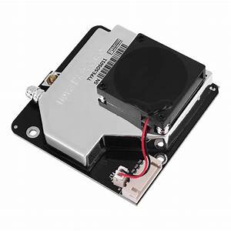

Fig:10 MQ-135.

**Reference:**

1. <https://search.yahoo.com/yhs/search;_ylt=Awr9LtahiwVfMNYAJS42nIlQ?p=mq7+gas+sensor&hsimp=yhs-newtab&hspart=Lkry&type=YHS_SECO_100&param1=mT_PedBI_R9essyp7Dy-1BjRPfCzNYStoqeKnGCGblTQsgWqoXWFQIaqYgJjn4vp08U8AAO6un9BB4PNQnIDsG46pV_Iz1lbyPnyjOs5YRz0Beh0c0-CJTAjuMHTlYpux_bXe-2LGILVgvS-lT2mQZRggsgrBX0EeWBYjHQkcmsXHGKrJbzAYbJ0c78FDoqWo76fI8QiXS0L1h8gpRjTLKg_2Sqz2-fnpcu2p2AHebEEMLy0xFkK1co1agK5TJU2-oLGsMBfvlulV9Pn68LhaGV-G1czyf6BxLCFU8LoUbgDAd02pB_hbpji-w%2C%2C&fr=yhs-Lkry-newtab&fr2=p%3As%2Cv%3Ai%2Cm%3Apivot&stype=web>
2. <https://images.search.yahoo.com/yhs/search;_ylt=Awr9LtagjAVfRmgA4p02nIlQ?p=pm10+sensor&ei=UTF-8&type=YHS_SECO_100&fr=yhs-Lkry-newtab&hsimp=yhs-newtab&hspart=Lkry&param1=mT_PedBI_R9essyp7Dy-1BjRPfCzNYStoqeKnGCGblTQsgWqoXWFQIaqYgJjn4vp08U8AAO6un9BB4PNQnIDsG46pV_Iz1lbyPnyjOs5YRz0Beh0c0-CJTAjuMHTlYpux_bXe-2LGILVgvS-lT2mQZRggsgrBX0EeWBYjHQkcmsXHGKrJbzAYbJ0c78FDoqWo76fI8QiXS0L1h8gpRjTLKg_2Sqz2-fnpcu2p2AHebEEMLy0xFkK1co1agK5TJU2-oLGsMBfvlulV9Pn68LhaGV-G1czyf6BxLCFU8LoUbgDAd02pB_hbpji-w%2C%2C&imgsz=small&fr2=p%3As%2Cv%3Ai>
3. <https://images.search.yahoo.com/yhs/search;_ylt=Awr9F6_6jAVfCTUAiAk2nIlQ?p=pm10+sensor&ei=UTF-8&type=YHS_SECO_100&fr=yhs-Lkry-newtab&hsimp=yhs-newtab&hspart=Lkry&param1=mT_PedBI_R9essyp7Dy-1BjRPfCzNYStoqeKnGCGblTQsgWqoXWFQIaqYgJjn4vp08U8AAO6un9BB4PNQnIDsG46pV_Iz1lbyPnyjOs5YRz0Beh0c0-CJTAjuMHTlYpux_bXe-2LGILVgvS-lT2mQZRggsgrBX0EeWBYjHQkcmsXHGKrJbzAYbJ0c78FDoqWo76fI8QiXS0L1h8gpRjTLKg_2Sqz2-fnpcu2p2AHebEEMLy0xFkK1co1agK5TJU2-oLGsMBfvlulV9Pn68LhaGV-G1czyf6BxLCFU8LoUbgDAd02pB_hbpji-w%2C%2C&fr2=p%3As%2Cv%3Ai#id=0&iurl=https%3A%2F%2Fimage-us.bigbuy.win%2Fupload%2Freceive_file%2F2018%2F02%2F06%2F04%2F22%2F5a792d6c377bd63498943.jpg&action=click>
4. <https://www.hindawi.com/journals/jat/2017/8204353/>